Project 2 Report
For: Nebraska Department of Transportation
Authors: Blake Green, Jazaria Birch, Ahmad Rezaie

Table of Contents

Table of Contents 2
Table of Figures 2
Table of Tables 2
Introduction 3
Methods 4
Results and Discussion 6
References 11

Table of Figures

Figure 1 - Flow Diagram of Tasks/Steps to Complete Project 4
Figure 2 - Excel Algebraic Sample Calculation for Water 4
Figure 3 - Example of Individual Function for Calculation of Water 5
Figure 4 - Screenshot of Weight Output Summary for Mix Design #1 7
Figure 5 - Screenshot of Weight Output Summary for Mix Design #2 8
Figure 6 - Screenshot of Weight Output Summary for Mix Design #3 9
Figure 7 - Screenshot of Weight Output Summary for Mix Design #4 10

Table of Tables

Table 1 - Mix Design #1 Table 7 of NDOT Report on Optimized Aggregates 6
Table 2 - Mix Design #2 Table 8 of NDOT Report on Optimized Aggregates 7
Table 3 - Mix Design #3 Table 9 of NDOT Report on Optimized Aggregates 8
Table 4 - Mix Design #4 9

Introduction
The client for this project is the Nebraska Department of Transportation, referred to as NDOT. NDOT is the government entity that is responsible for all transportation systems in Nebraska. They plan, design, and construct major highways, airport systems, and a majority of roads. Because of their nature of work, they use all kinds of concrete. The concrete needs to be tailored to and evaluated for each individual project. Currently NDOT uses an excel sheet to calculate the mix design details by manual entry. NDOT has tasked us with taking the excel sheet logic and implementing that logic into a python-based code so that the process is automated based off of user input prompts. This will streamline efficiency for NDOT and will help make sure that all calculations are error free and consistent.
Our objective for this project was to complete it in a timely manner and for the product to be satisfactory to the client, NDOT. Throughout the course of the project python coding was applied to complete the main task and research based on the client’s resources was used to find and evaluate mix designs.

Methods
The methods for this project involved converting the NDOT mix design workflow spreadsheet, from excel, into an automated python program. The goal was to keep the same logic and structure of the spreadsheet and transfer it into a code-based file that computes the weights for one cubic yard of concrete matching NDOT’s design procedures. Figure 1 shows a clear flow diagram of the order and description of how the task would be completed.
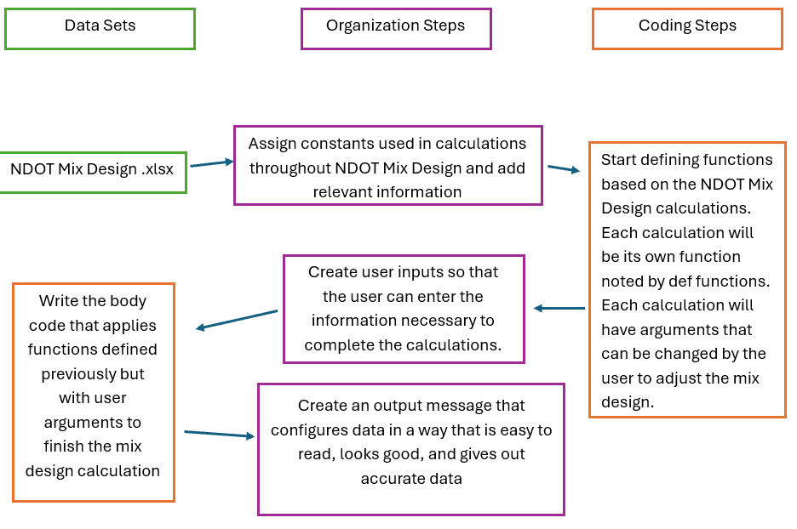
Figure 1 - Flow Diagram of Tasks/Steps to Complete Project
The first step was to define any constants used and general metadata. The project name and client were identified first for the metadata. Then the volume of cubic feet for 1 cubic yard was defined as well as the unit weight of water. The last piece of relevant information was to add the specific gravities of cement, fly ash, silica fume, and other SCM.
The second step was to translate the excel functions into python. The spreadsheet has a combination of algebraic formulas and cell references. Each formula was reproduced as an individual function corresponding to a specific stage of the overall calculation. One example is the water calculation function. Figure 2 shows an algebraic expression of how excel computed this value. Then Figure 3 shows a screenshot of code written to do this same calculation in python that can be applied any time by calling the function.
Figure 2 - Excel Algebraic Sample Calculation for Water
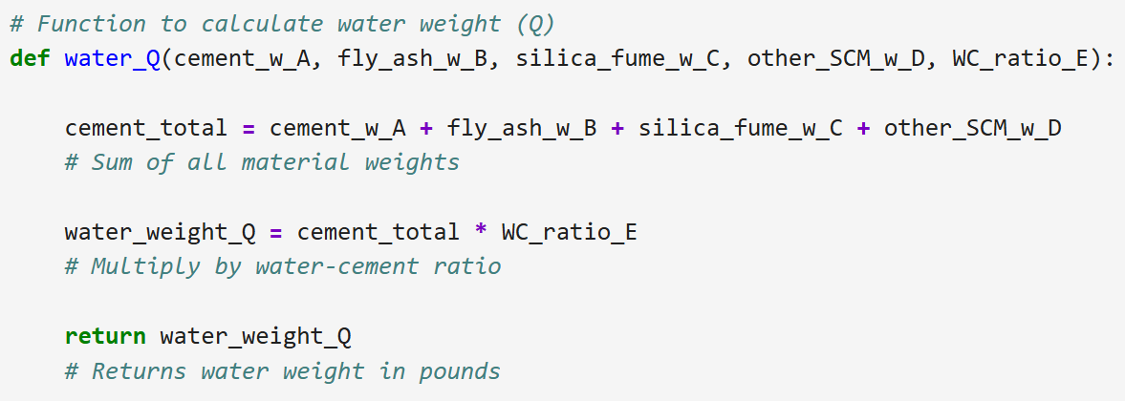
Figure 3 - Example of Individual Function for Calculation of Water
There were multiple other functions that had to be transcribed into the python code. The same process was applied for each function. All that were included were the volume, air content, water volume, aggregate volume, and aggregate weight calculations. By separating each step into a singular function, the code can call the function whenever it is needed for the calculation while still mirroring the mix design spreadsheet.
The third step was to generate the body of the main code block. This part of the code fulfills the client’s request for the code to include user inputs. The user input prompts were created, and the main code starts by asking the user for multiple pieces of information. This included the weights of the cementitious materials (cement, fly ash, silica fume, and other SCM), target water cement ratio, target air content, aggregate proportions (fine, coarse, and other), and specific gravities of cementitious materials and aggregates. The code then uses these inputs and calls the previously made calculations in the correct order to complete the final weight chart.
The output chart is made by a variety of print statements. It is separated by lines made up of dashes and displays all necessary information. The title, project number, and concrete class are all at the top of the chart. Then the weight information is displayed. The print statements use f strings so that they take the computed value based off the user inputs and transcribes it into the statement. The f strings are also used to limit the number of decimals displayed. All weights displayed in this chart are for one cubic yard of concrete.

For future users, there are a few parameters that need to be followed when using this code. First, the program will ask for multiple clearly defined inputs: cementitious materials (cement, fly ash, silica fume, and other SCM), target water-cement ratio, target air content, aggregate proportions (fine, coarse, and other), and the specific gravities for each material. These inputs allow the program to obtain all necessary values for the calculation. It is important to note that the water-cement ratio will rarely exceed 1. The aggregate proportions should also be checked to make sure that they add up to 100%. If it exceeds or is below 100% then the calculation will be inaccurate. After letting the program calculate the weights and dispense the weight output summary these weights and user inputs should be checked to make sure, they appear to be in normal range and that all inputs were entered correctly.

Results and Discussion
The client requested that four different mix designs be used to demonstrate how the code works and for those mix designs to be evaluated. All mix designs were taken from the client provided resource, Nebraska Department of Roads (2002).
The first mix design, shown in Table 1, was the NDOT 47B mixture. This table was taken from the client-provided resource (Nebraska Department of Roads, 2002). This table specifies a mixture of 610 lbs of cement, 238 lbs of water, and 2908 lbs of aggregates per cubic yard. The target water-cement ratio was .39 and the air content was 7.5%. These values represent a standard NDOT 47B concrete which is typically used for structural applications like pavement, slabs, and other general uses.
Table 1 - Mix Design #1 Table 7 of NDOT Report on Optimized Aggregates
Components | Weights (1 Cubic Yard)
Cement | 610 lbs
Aggregate:  Pine Bluffs Sand, & Gravel Aggregate | 2908 lbs
Target W/SCM Ratio | 0.39
Target %Air Content | 7.5%
Water | 238 lbs

These parameters were entered into the Python program with aggregate proportion of 40% fine and 60% coarse. This reflects a typical distribution. The program calculated the material volumes and converted them into final weights and produced these weights into a weight output table shown in Figure 4. The figure indicates that 1195 lbs of fine aggregate and 1826 lbs of coarse aggregate are used in one cubic yard of concrete. Overall, the first mix design serves as a baseline concrete mix design to compare the other three designs too.
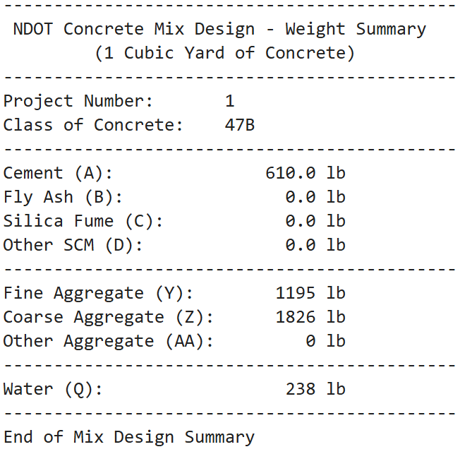
Figure 4 - Screenshot of Weight Output Summary for Mix Design #1
The second mix design is the 47BR mixture shown in Table 2. This design reduces the cement content to 564 lbs while keeping the water-cement ratio and air content consistent with mix design 1. According to the NDOT resource, 47BR concrete is common for applications that require enhanced freeze/thaw resistance like bridge decks or exposed components.
Table 2 - Mix Design #2 Table 8 of NDOT Report on Optimized Aggregates
Components | Weights (1 Cubic Yard)
Cement | 564 lbs
Aggregate:  Pine Bluffs Sand & Gravel Aggregate | 2908 lbs
Target W/SCM Ratio | 0.39
Target % Air Content | 7.5%
Water | 238 lbs

Using the values from the table above, the Python program generated a weight output table for this mix design. This is shown in Figure 5.
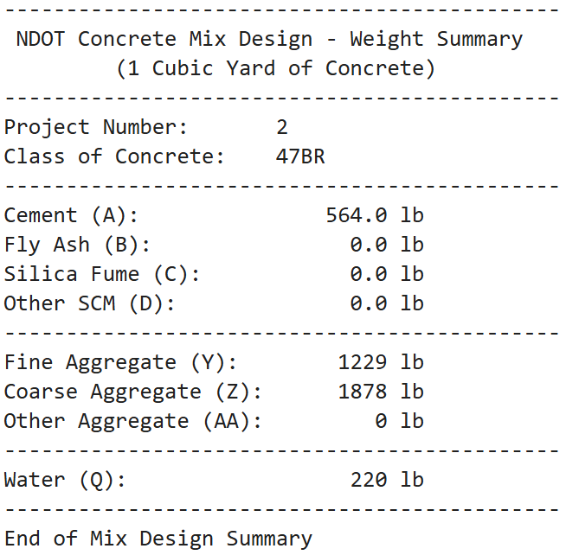
Figure 5 - Screenshot of Weight Output Summary for Mix Design #2
The program computed the aggregate weights to have 1229 lbs of fine aggregate and 1878 lbs of coarse aggregate per one cubic yard of concrete. The water weight was calculated to be 220 lbs. This mixture uses less cement and more total aggregate compared to the first mix design. This supports the idea that this concrete is durability focused on specific applications in projects that are necessary to have material that is freeze/thaw resistant.
The third mix design is nearly the same as the first mix design but has an increased water cement ratio of 0.41 and a water content of 231 lbs. These values are shown in Table 3 along with all values used for the calculation. This slightly higher water content will increase the workability of the concrete, but a drawback is that the concrete will inevitably be less durable than other lower water 47BR concrete mixes.
Table 3 - Mix Design #3 Table 9 of NDOT Report on Optimized Aggregates
Components | Weights (1 Cubic Yard)
Cement | 564 lbs
Aggregate:  Pine Bluffs Sand & Gravel Aggregate | 2908 lbs
Target W/SCM Ratio | 0.41
Target % Air Content | 7.5%
Water | 231 lbs

After running these values through the Python script, the program gave a weight output summary shown in Figure 6. The program calculated 1217 lbs of fine aggregate and 1860 lbs of coarse aggregate which is lower than the second mix design because of the increased water volume which occupies a larger portion of the volume for this mix design. This design shows how marginal changes to the water-cement ratio can have a very noticeable effect on the aggregate quantities if the cement content stays constant.
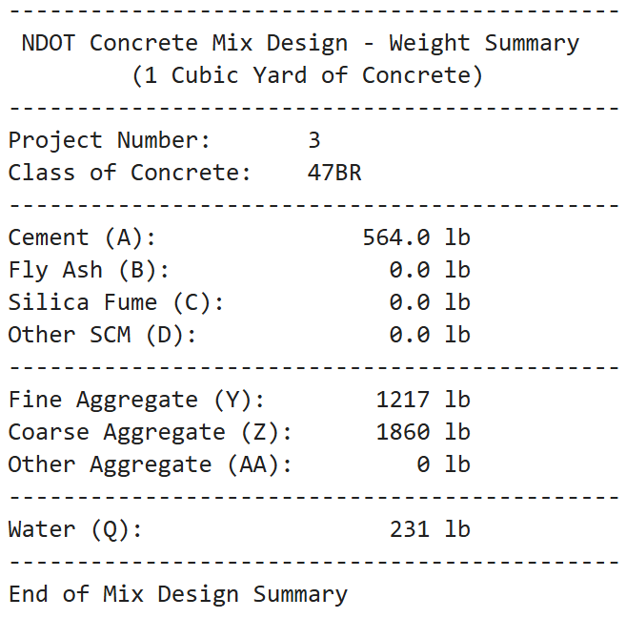
Figure 6 - Screenshot of Weight Output Summary for Mix Design #3
The fourth and final mix design that was evaluated is shown in Table 4. This mix design is a concrete class 47BR mixture and incorporates a water reducing mix of materials. While the cement value is the same as the previous mixture you can see that the water weight is lower than all mixtures shown in this report. This mix design was made to show a water reducing mixture and adjusted the aggregate weights and water weights to accommodate.
Table 4 - Mix Design #4
Components | Weights (1 Cubic Yard)
Cement | 564 lbs
Aggregate | 3110 lbs
Target W/SCM Ratio | 0.39
Target % Air Content | 7.5%
Water | 220 lbs

The program’s output for this mix design is shown in Figure 7. This was generated using aggregate percentages of 35% fine and 65% coarse. For this mix the program found that the mixture needed 1075 lbs of fine aggregate and 2035 lbs of coarse aggregate while keeping the water-cement ratio and air content consistent with previous mix designs. A water-reducing design could be useful for NDOT because it will improve the workability of the concrete without increasing the water-cement ratio. This is useful because it then can maintain the strength and durability that is needed for NDOT’s applications.
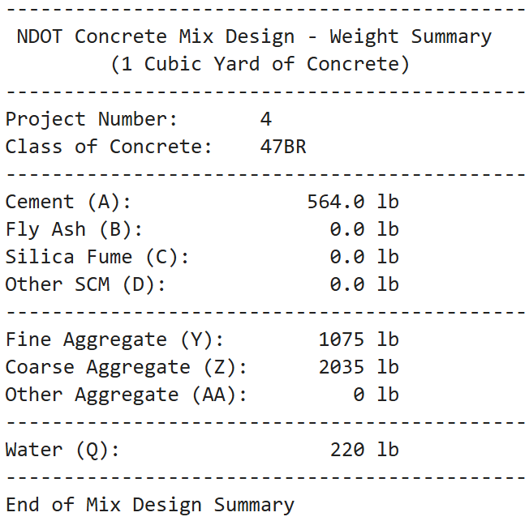
Figure 7 - Screenshot of Weight Output Summary for Mix Design #4

References
Nebraska Department of Roads. (2002). Optimized aggregates gradations for Portland cement concrete mix designs evaluation (Materials & Research Division Report). Nebraska Department of Roads.
Nebraska Department of Transportation. (n.d.). NDOT Concrete Mix Excel [Microsoft Excel spreadsheet]. https://dot.nebraska.gov/media/jp3paote/mix-design-submittal.xlsx

